**6.6 Similarity Proofs Classwork & HW**

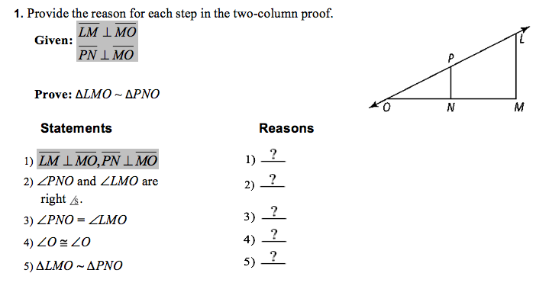

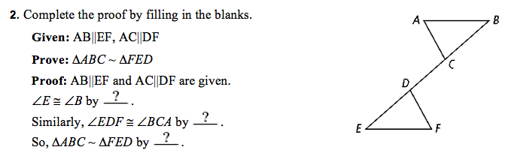

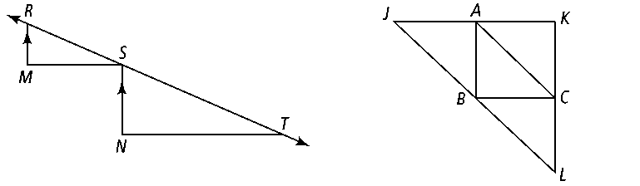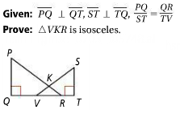

**3. Given:** *RM||SN*, RM MS, SN NT

**Prove:** Δ*RSM* ~ Δ*STN*

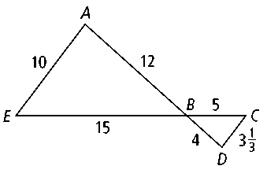**4. Given: **and intersect at *B.*

**Prove:** ∆*ABE* ~ ∆*DBC*

**5. Given:** *A* bisects *JK*, *C* bisects *KL*, *B* bisects *JL*

**Prove:** Δ*JKL* ~ Δ*CBA*

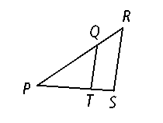

**Given:** QT || RS

**Prove:** ∆*PQT* ~ ∆*PRS*





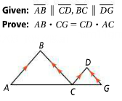

**Optional Extra Credit Problem (worth 2 points of extra HW credit)**

Screen%20Shot%202017-01-08%20at%206.34.40%20PM.png